

**Computer Science or Information Technology**

Instructor: **Dawei Li, Ph.D.**

Day, Month, Year

Day

CSIT 501

Department of CSIT

Assessment

Module-4

Hidalgo, Rafael

Exercise 4.1,

For each of the following pairs, identify which one represents a class and which one represents an object of that class?

a. Weekdays, Friday: Weekdays is the class. The object is Friday.

b. Java, Language: Java is the Object. Language is the class.

c. Bird, Eagle: Bird is the class. Eagle is the object.

d. Bob, Employee: Bob is the object. Employee is the class.

e. Student, Alice: Student is the class. Alice is the object.

Exercise 4.2,

List some attributes and operations that might be defined for a class called WindowPane that represents a window pane.

Some attributes this class may have is to determine whether the window pane is open or close. Also one could set the height and width of the window pane.

Two operations that this class may have is to open or close the window pane. One could also get the dimensions of the window pane using a gettter.

Exercise 4.4,

List some attributes and operations that might be defined for a class called Course that represents a college course (not a particular offering of a course, just the course in general).

Some attributes this class may have is Course name, Course teacher, Course Student, and Course population size.

Some operations this class may have is getCourseName, setCourseName. It may also have methods to add students and teachers to a database.

Exercise 4.5,

Write a method called synonyms that prints at least two synonyms of a word when invoked. The method should accept no parameters and return no value.

public void printTwoSynonyms()

Exercise 4.7,

Write a method called random100 that returns a random integer in the range of 1 to 100 (inclusive).

**public** **int** random100()

{

randomNum = (**int**)(Math.*random*() * 100) + 1;

**return** randomNum;

}

Exercise 4.9,

Write a method called randomColor that creates and returns a Color object that represents a random color. Recall that a Color object can be defined by three integer values between 0 and 255, representing the contributions of red, green, and blue (its RGB value).

**final** **int** MAX = 256;

**public** Color randomColor ()

{

Random generator = **new** Random();

**int** rRed = generator.nextInt(MAX);

**int** rGreen = generator.nextInt(MAX);

**int** rBlue = generator.nextInt(MAX);

**return** **new** Color(rRed, rGreen, rBlue);

Exercise 4.11,

Suppose you have a class called Child with an instance data value called age. Write a getter method and a setter method for age.

**public** **class** Child {

**private** **int** age;

**public** Child()

{

age = 0;

}

**public** **void** setAge(**int** value)

{

age = value;

}

**public** **int** getAge()

{

**return** age;

}

**public** String toString()

{

String result = Integer.*toString*(age);

**return** result;

}

}

Exercise 4.12,

Draw a UML class diagram that shows the relationships among the classes used in the Transactions program.

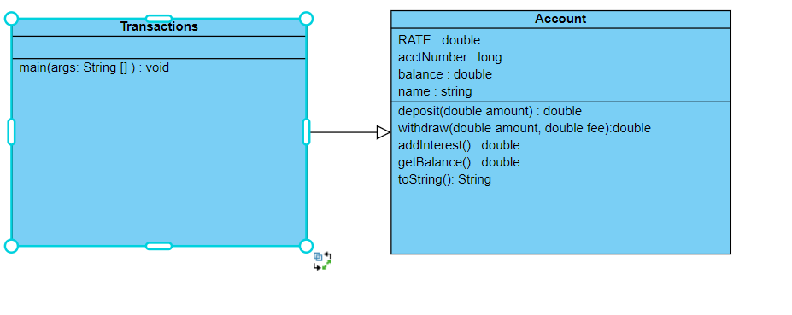

Exercise 4.13

Draw a UML class diagram that shows the relationships among the classes used in the PushCounter program.

